COVER PAGE

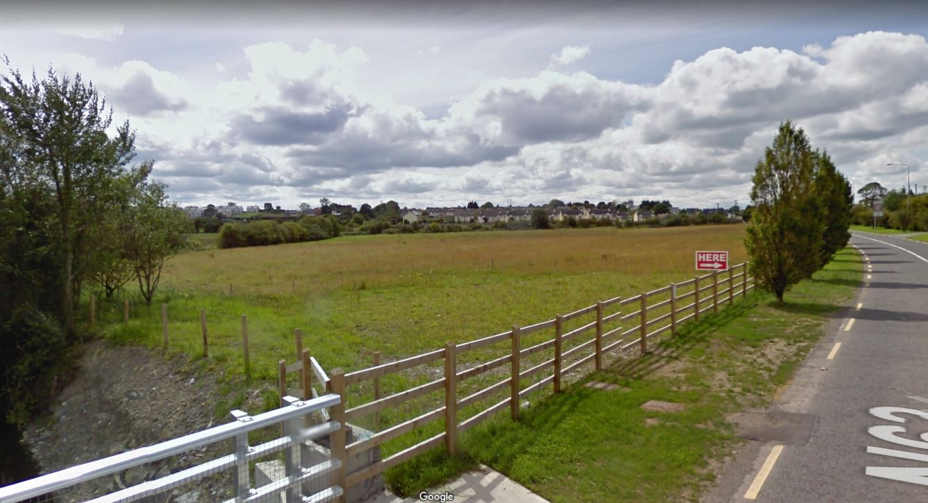
Proposed Construction of 2 No. Industrial/Commercial Warehousing Units at Knock, Lanesborough, County Longford.

SCHEDULE

- Development Description
- Newspaper Notice
- Site Notice
- Site Layout Plan, Plans, Section & Elevations

